**Task:**

Using Lambda Function to Start & Stop the EC2 Instance Using Cloud watch Events.

1) Create function to start ec2 instance at 10 AM IST if instance has tag ec2_start = "true".

2) Create function to stop ec2 instance at 10 PM IST if instance has tag ec2_stop = "true".

3) Outcome is ec2 instance should start or stop automatically based on cron job schedule.

**Solution:-**

**Step 1: Launch EC2 instance**

* Sign in to the AWS Management Console.
* Click on the EC2 service.
* Click on the Launch Instance button to create a new instance.

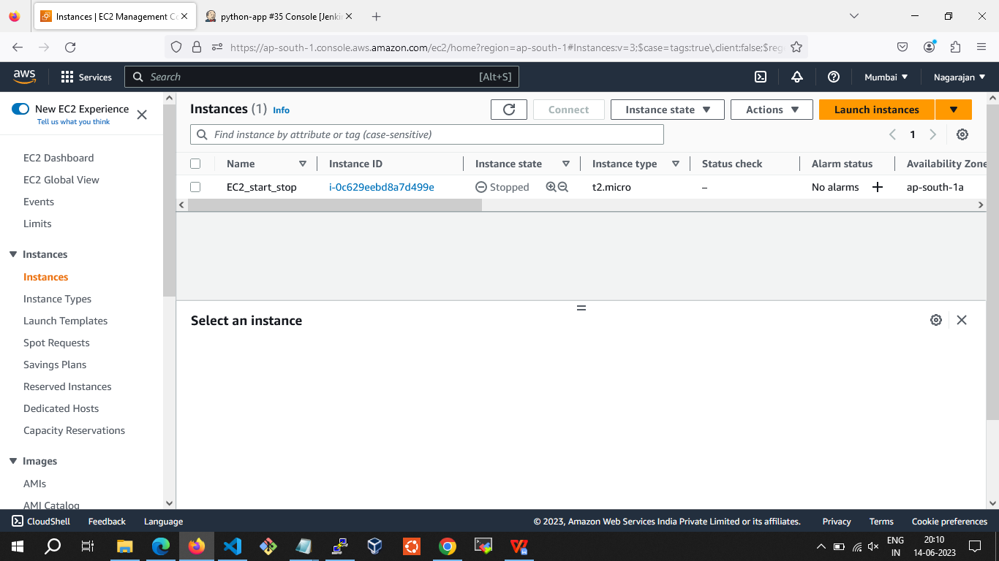

* Add the tag ec2_start and ec2_stop

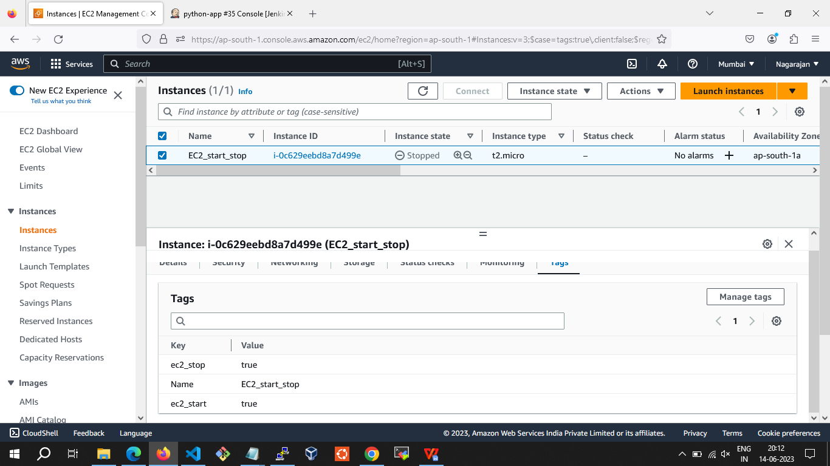

**Step 2: Creating IAM Roles for a service**

* In the navigation pane of the console, click Roles and then click on "Create Role". The screen appears shown below on clicking Create Role button.

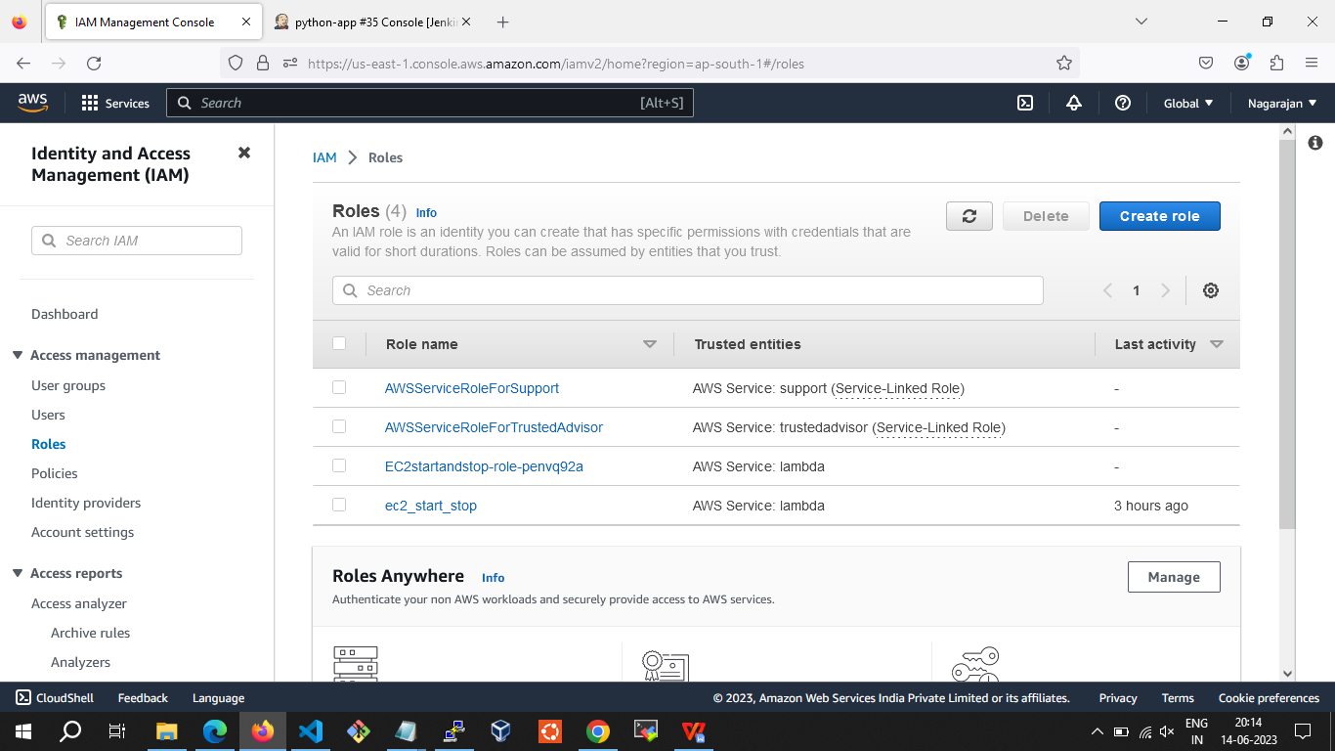

* Choose the service and create policy to start instances and stop instances.

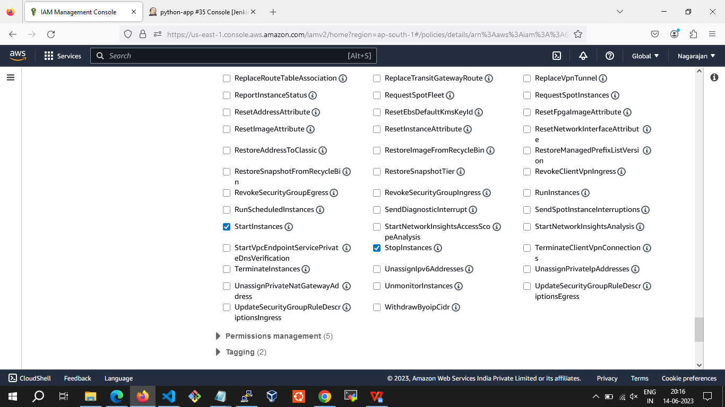

* Select the managed policy that attaches the permissions to the service.

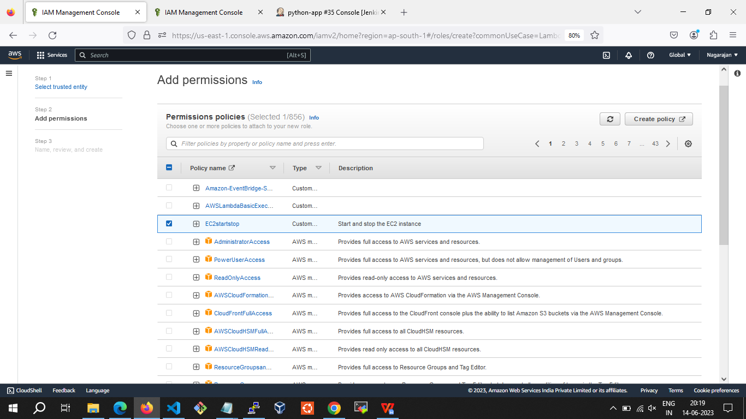

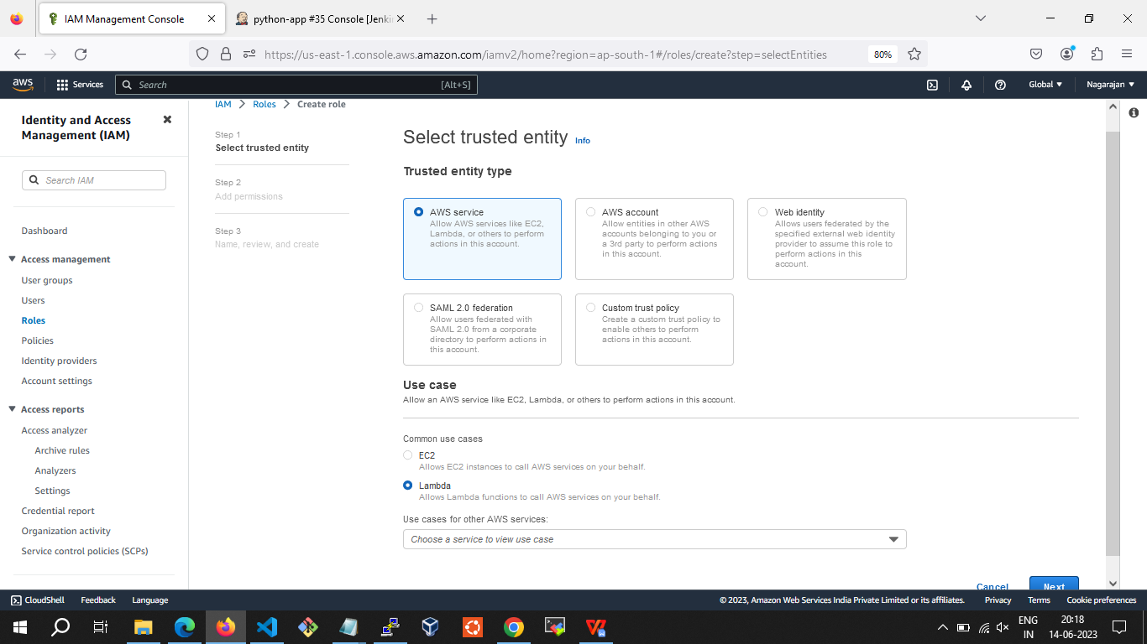

* In a role name box, enter the role name that describes the role of the service, and then click on "Create role".

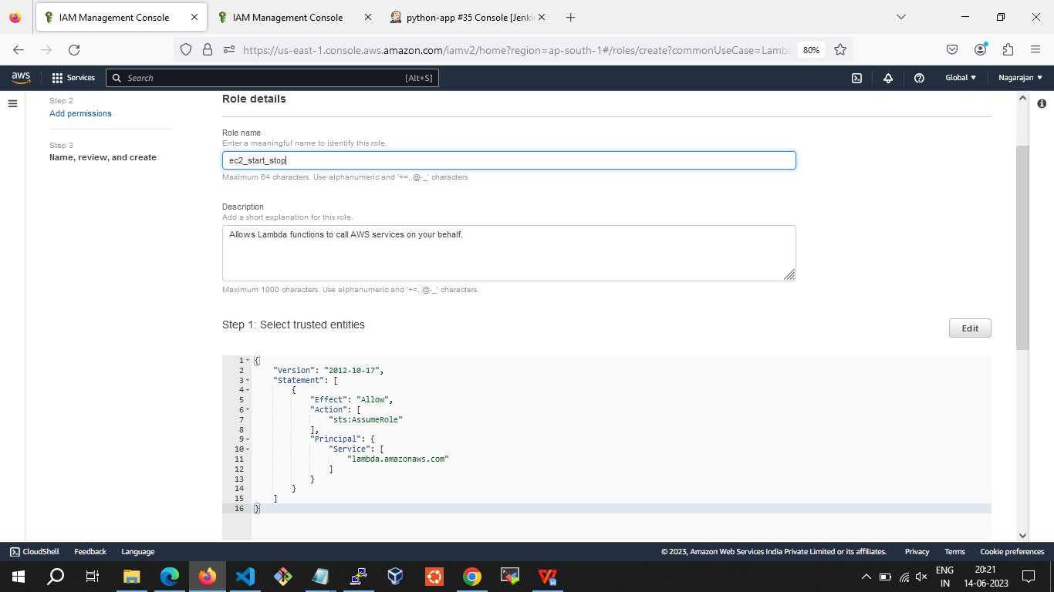

**Step 3: Creating Lambda function**

* Click on the Lambda service.
* Click on the Create function to create a new function.

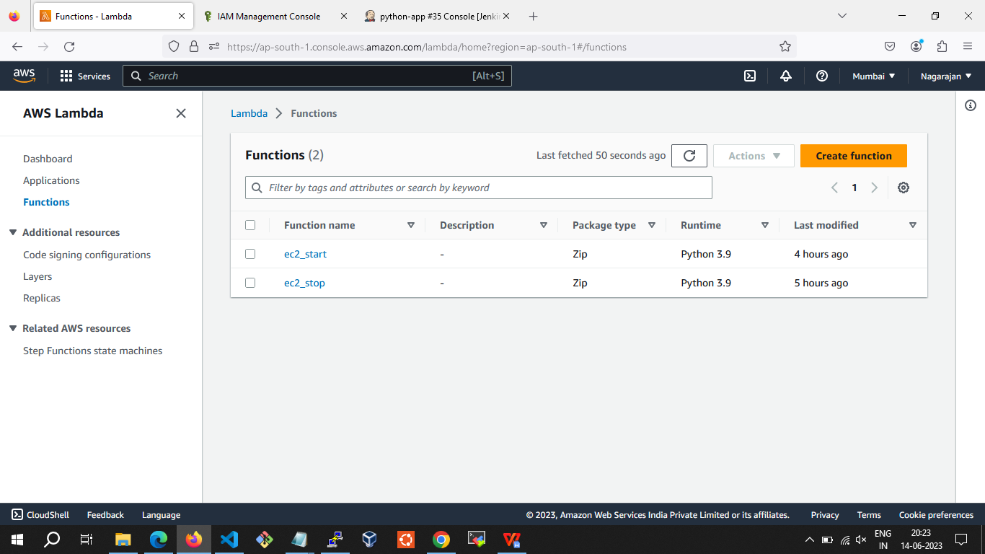

* Now, we create the Lambda function by using the Author from scratch.

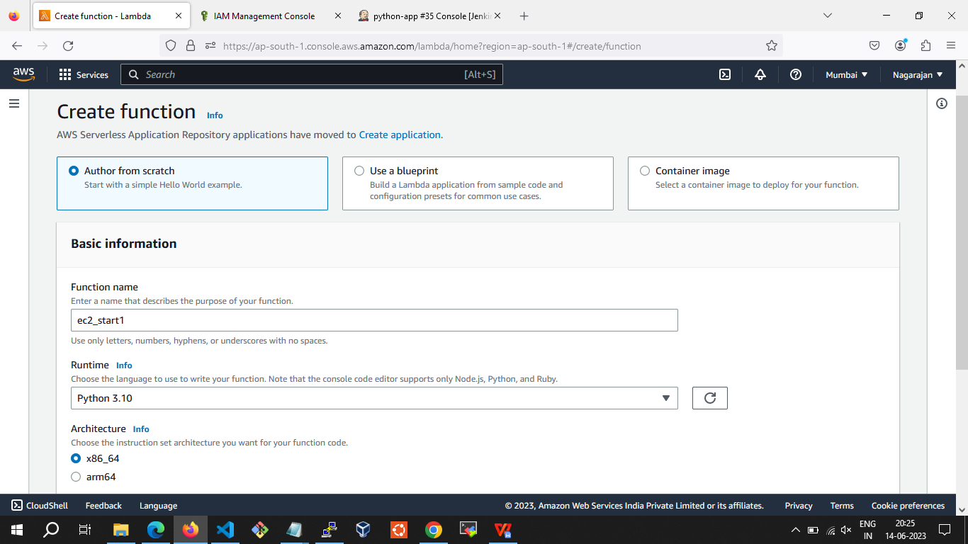

* I already created a role, and my role name is ec2_start_stop

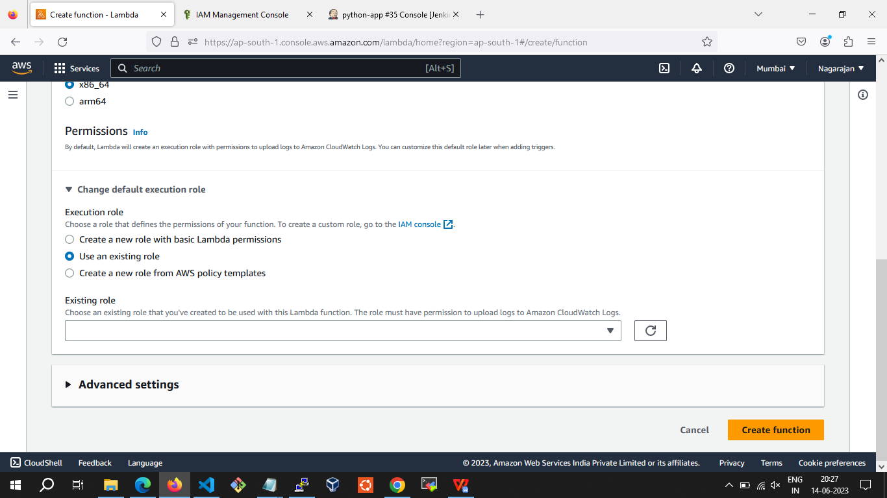

* Click on the Create function.

**Step 4: Creating Cloudwatch rule for triggering**

* In the navigation pane, Create rule.

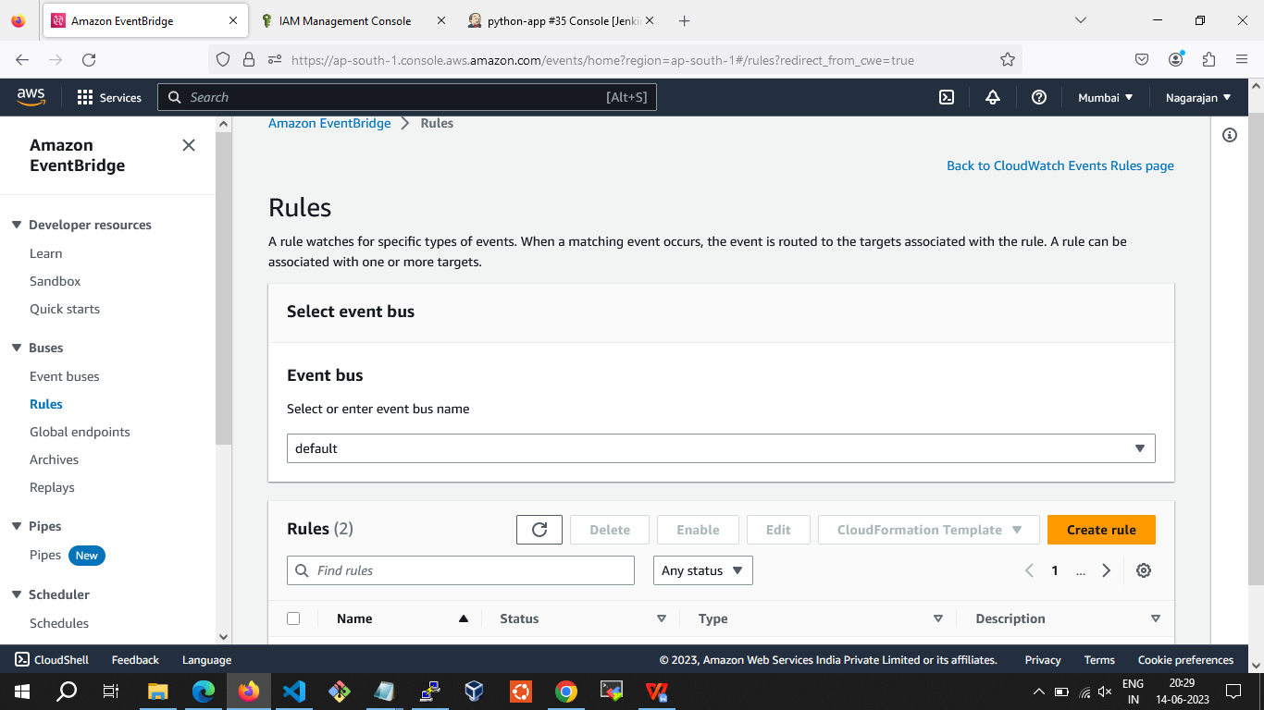

* For Event Source, Choose Schedule(Cron job).

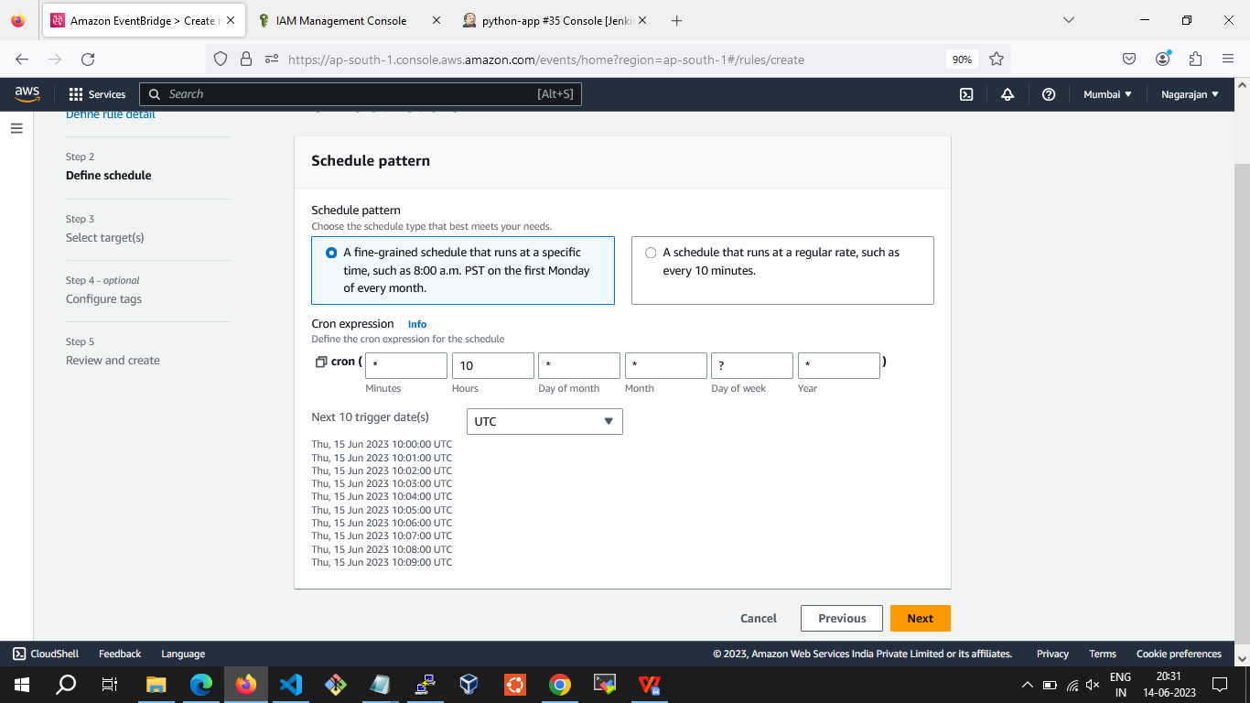

* For Targets, choose Add target, Lambda function.
* For Function, select the Lambda function that you created.
* Choose Create rule.

